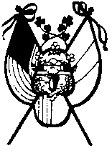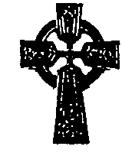 Please sign this petition for the cause of:

“THE BLESSED IRISH HUNGER MARTYRS”

They suffered and died for their Catholic Faith during the years of the man-made famine in Ireland 1845-1850. They died on coffin ships and in distant lands as a direct result of diseases caused by the hunger they had to endure because of their Catholic Faith. These petitions will be sent to Rome asking for Universal Beatification for these Martyrs in recognition of their faith and sacrifices.

NAME ADDRESS

Please return signed petitions to: Bill Fahey, AOH Div 5, P.O. Box 472, Shirley, NY 11967
Please make additional copies if needed

